Functional Requirements Document (FRD)
Project: AutoPrice AI - Used Vehicles Price Prediction System
Version: 1.0
Prepared for: AutoPrice AI Development & Stakeholder Teams

Table of Contents
- Introduction
1.1. Purpose
1.2. Scope
1.3. Definitions, Acronyms, and Abbreviations
1.4. References
1.5. Document Overview
- Overall Description
2.1. Product Perspective
2.2. Product Functions (High-Level)
2.3. User Classes and Characteristics
2.4. Operating Environment
2.5. Design and Implementation Constraints
2.6. Assumptions and Dependencies
- System Architecture
3.1. High-Level Architectural Overview
3.2. Component Diagram
3.3. Data Flow Diagram
3.4. Use Case Diagram
- Functional Requirements
4.1. Module 1: Vehicle Data Input & Validation
4.2. Module 2: Market Data Integration & Processing
4.3. Module 3: Price Prediction Engine
4.4. Module 4: Regulatory Compliance Module
4.5. Module 5: User Interface & Experience
4.6. Module 6: Integration & API Services
4.7. Module 7: Administration & Analytics
- Non-Functional Requirements
5.1. Performance Requirements
5.2. Security Requirements
5.3. Usability Requirements
5.4. Reliability & Availability
5.5. Scalability & Maintainability
5.6. Compliance Requirements
- Data Requirements
6.1. Data Input Specifications
6.2. Output Data Structure
6.3. Data Storage & Retention
6.4. Data Privacy & Protection
- External Interface Requirements
7.1. User Interfaces
7.2. Hardware Interfaces
7.3. Software Interfaces
7.4. Communication Interfaces
- Appendices
Appendix A: PlantUML Diagrams - Source Code
Appendix B: Supported Vehicle Specifications
Appendix C: EU Emission Standards Reference
Appendix D: Revision History

1. Introduction
1.1. Purpose
This Functional Requirements Document (FRD) defines the functional specifications for the AutoPrice AI system—a specialized used vehicle price prediction platform optimized for European markets. The document serves as the foundation for design, development, testing, and validation, ensuring all stakeholders share a common understanding of system capabilities and requirements.
1.2. Scope
The AutoPrice AI system provides data-driven price predictions for used vehicles in European markets, with initial focus on Belgium. The scope includes:
In-Scope:
- Ingestion and validation of vehicle specifications (make, model, year, mileage, etc.)
- Integration of market data from multiple European sources
- Consideration of EU emission standards and regulatory factors
- Dual prediction methodologies: LLM-based reasoning and statistical modeling
- Web-based interface for individual users and dealers
- RESTful APIs for integration with dealer platforms and marketplaces
- Administrative dashboard for system management
Out-of-Scope:
- Real-time vehicle condition assessment (physical inspections)
- Vehicle history report generation (accident history, service records)
- Financing or insurance premium calculations
- New vehicle pricing
- Markets outside Europe
1.3. Definitions, Acronyms, and Abbreviations
Table: Terminology Definitions
Term | Definition
LLM | Large Language Model. Used for contextual price reasoning and explanation generation.
CO₂ | Carbon Dioxide. Emission metric critical for European regulatory compliance.
EURO | European emission standard classification (e.g., Euro 5, Euro 6).
VIN | Vehicle Identification Number. Unique code for identifying individual vehicles.
API | Application Programming Interface.
CRM | Customer Relationship Management system.
DMS | Dealer Management System.
MAE | Mean Absolute Error. Key performance metric for prediction accuracy.
RMSE | Root Mean Square Error. Secondary accuracy metric.
SLA | Service Level Agreement.
1.4. References
- Project Charter: AutoPrice AI
- EU Regulation (EC) No 715/2007: Emission standards for light passenger and commercial vehicles
- Market Analysis: European Used Vehicle Market 2024
- Data Privacy: GDPR Regulation (EU) 2016/679
1.5. Document Overview
This document systematically details the functional requirements of AutoPrice AI, beginning with overall system context, progressing through architectural views, and concluding with specific module requirements, non-functional standards, and interface specifications.

2. Overall Description
2.1. Product Perspective
AutoPrice AI operates as a standalone SaaS platform that can also be embedded via APIs into existing automotive platforms. It sits between market data sources (listings, historical sales) and end-users (buyers, sellers, dealers), transforming raw vehicle and market data into actionable price intelligence.
2.2. Product Functions (High-Level Summary)
- Ingest detailed vehicle specifications from users or integrated systems.
- Validate input data against European vehicle databases and logical rules.
- Collect & Process real-time and historical market data from European sources.
- Analyze regulatory factors (emission class, CO₂, local taxes).
- Execute price predictions using dual methodologies: statistical models and LLM-based reasoning.
- Generate comprehensive price reports with confidence intervals and explanations.
- Provide web interface for individual queries and batch processing for dealers.
- Expose prediction capabilities via secure APIs.
- Learn from user feedback and new market data to improve accuracy.
2.3. User Classes and Characteristics
Table: User Classes and Requirements
User Class | Characteristics & Key Requirements
Individual Buyer/Seller | Casual user. Needs simple, quick price estimate. Requires transparency and explanation of factors affecting price.
Used Car Dealer | Professional user. Requires batch processing, API integration, detailed analytics, and competitive market analysis.
Fleet Manager | Manages large vehicle portfolios. Needs depreciation forecasting, bulk valuations, and regulatory impact reports.
Marketplace Admin | Integrates pricing into platform. Requires high-volume API access, SLA guarantees, and customizable prediction rules.
System Administrator | Manages system configuration, user accounts, data source connections, and monitors system health.
2.4. Operating Environment
Software Environment:
- Cloud-native deployment (AWS/Azure/Google Cloud)
- Backend: Python-based microservices, containerized (Docker/Kubernetes)
- Frontend: React/Next.js web application
- Databases: PostgreSQL (structured), Redis (caching), blob storage
- AI/ML: TensorFlow/PyTorch for statistical models, OpenAI/Anthropic APIs or local LLMs
Hardware Environment:
- Server-side: Standard cloud compute instances; GPU optional for LLM inference
- Client-side: Modern web browsers (Chrome 90+, Firefox 88+, Safari 14+)
2.5. Design and Implementation Constraints
- Must comply with GDPR for all user data processed and stored
- Prediction models must be explainable to meet EU "right to explanation" guidelines
- Must support at least 8 major European vehicle brands in initial release
- System must be available in English, French, and Dutch at launch
- API response time must not exceed 2 seconds for 95% of requests
- Must maintain backward compatibility for API versions for at least 12 months
2.6. Assumptions and Dependencies
Assumptions:
- Reliable access to European used vehicle listing data via third-party providers
- Vehicle specification data provided by users is generally accurate
- Market data providers maintain stable API interfaces with reasonable uptime
- European emission standards remain stable during the development period
Dependencies:
- Availability of current and historical EU emission regulation data
- Third-party mapping services for regional price variation adjustments
- Reliable VIN decoding services for European vehicles
- Continuous access to market data APIs from automotive listing platforms

3. System Architecture
3.1. High-Level Architectural Overview
The system follows a modular microservices architecture with clear separation of concerns:
Presentation Layer: Web Application and API Gateway
Application Layer: Core business services (Data Ingestion, Prediction Engine, Compliance Service)
Data Layer: Multiple databases for different data types (vehicle specs, market data, predictions)
AI/ML Layer: Dedicated services for statistical models and LLM orchestration
3.2. Component Diagram
3.3. Data Flow Diagram
3.4. Use Case Diagram

4. Functional Requirements
4.1. Module 1: Vehicle Data Input & Validation
Table: Vehicle Data Input Requirements
Req. ID | Requirement Description | Priority
FR-1.1 | The system shall provide a web form for manual entry of vehicle specifications: Make, Model, Year, Mileage, Fuel Type, Transmission, etc. | Must Have
FR-1.2 | The system shall accept vehicle data via VIN (Vehicle Identification Number) decoding for supported European brands. | Must Have
FR-1.3 | The system shall validate all input fields (e.g., mileage must be positive number, year within valid range 1990-current). | Must Have
FR-1.4 | The system shall cross-reference input data with European vehicle databases to verify model configurations exist. | Should Have
FR-1.5 | The system shall support batch upload of vehicle data via CSV/Excel templates for dealer users. | Must Have
FR-1.6 | The system shall calculate and display vehicle age based on model year and current date. | Must Have
FR-1.7 | The system shall infer missing but inferable data (e.g., emission standard based on model year and fuel type if not provided). | Should Have
FR-1.8 | The system shall provide autocomplete suggestions for Make and Model fields based on popular European vehicles. | Must Have
FR-1.9 | The system shall validate that provided CO₂ emissions are within reasonable range for the vehicle type and fuel. | Should Have
4.2. Module 2: Market Data Integration & Processing
Table: Market Data Requirements
Req. ID | Requirement Description | Priority
FR-2.1 | The system shall connect to at least three (3) major European used vehicle listing platforms via API to collect current asking prices. | Must Have
FR-2.2 | The system shall collect historical sales transaction data from partnered dealership networks (anonymized). | Should Have
FR-2.3 | The system shall process raw market data to clean outliers (e.g., remove prices >200% or <20% of market average for same spec). | Must Have
FR-2.4 | The system shall calculate regional price adjustments for major European regions/countries (e.g., price premium in Germany vs. Belgium for same vehicle). | Must Have
FR-2.5 | The system shall track supply/demand metrics (days on market, listing views) for popular models. | Could Have
FR-2.6 | The system shall update market data at least once every 24 hours. | Must Have
FR-2.7 | The system shall maintain a 90-day history of market price trends for major vehicle segments. | Must Have
FR-2.8 | The system shall identify seasonal price patterns (e.g., convertible prices in summer vs. winter). | Could Have
4.3. Module 3: Price Prediction Engine
Table: Prediction Engine Requirements
Req. ID | Requirement Description | Priority
FR-3.1 | The system shall implement a statistical prediction model (e.g., Gradient Boosting, Random Forest) trained on historical European market data. | Must Have
FR-3.2 | The system shall implement an LLM-based reasoning engine that analyzes vehicle context, market trends, and qualitative factors to adjust base statistical predictions. | Must Have
FR-3.3 | The system shall allow users to select the prediction methodology (Statistical, LLM-Reasoned, or Combined). | Must Have
FR-3.4 | For each prediction, the system shall generate a price range (low, fair, high) with confidence intervals. | Must Have
FR-3.5 | The system shall provide a feature importance breakdown showing which factors (mileage, age, etc.) most impacted the prediction. | Must Have
FR-3.6 | The LLM engine shall generate a natural language explanation of the predicted price (e.g., "Price is reduced by 15% due to high mileage relative to age"). | Must Have
FR-3.7 | The system shall achieve a Mean Absolute Error (MAE) of less than 8% compared to actual sales prices for the Belgian market. | Must Have
FR-3.8 | The system shall provide a "market competitiveness" score indicating how the predicted price compares to similar listings. | Should Have
FR-3.9 | The system shall adjust predictions based on vehicle color popularity for the specific region. | Could Have
4.4. Module 4: Regulatory Compliance Module
Table: Regulatory Compliance Requirements
Req. ID | Requirement Description | Priority
FR-4.1 | The system shall map vehicle specifications (year, fuel type) to EU emission standard (Euro 1-6). | Must Have
FR-4.2 | The system shall incorporate known future regulatory changes (e.g., low-emission zone expansions) into price depreciation forecasts. | Should Have
FR-4.3 | The system shall adjust predicted price based on CO₂ emissions and local tax structures for key European countries. | Must Have
FR-4.4 | The system shall flag vehicles at risk of regulatory obsolescence (e.g., diesel vehicles banned from certain city centers). | Must Have
FR-4.5 | The system shall provide a "compliance score" (0-100) indicating how well a vehicle meets current and near-future regulations. | Could Have
FR-4.6 | The system shall calculate estimated annual tax liability for the vehicle in selected European countries. | Should Have
FR-4.7 | The system shall identify vehicles eligible for green vehicle incentives or subsidies in specific regions. | Could Have
4.5. Module 5: User Interface & Experience
Table: User Interface Requirements
Req. ID | Requirement Description | Priority
FR-5.1 | The web interface shall provide a simple "Quick Estimate" form for casual users with minimal required fields (Make, Model, Year, Mileage). | Must Have
FR-5.2 | The interface shall provide an "Advanced Estimate" form with all vehicle specification options for professional users. | Must Have
FR-5.3 | Results shall be displayed in a clear report format with visual indicators (price gauge, trend graphs). | Must Have
FR-5.4 | Users shall be able to save vehicle profiles and predictions to their account. | Must Have
FR-5.5 | The interface shall allow side-by-side comparison of up to 3 vehicles. | Should Have
FR-5.6 | The system shall provide localized interfaces in English, French, and Dutch, including currency (EUR) and unit (km) formatting. | Must Have
FR-5.7 | The interface shall be fully responsive and functional on mobile devices (smartphones, tablets). | Must Have
FR-5.8 | Users shall be able to download prediction reports as PDF documents. | Should Have
FR-5.9 | The system shall provide tooltips and help text explaining each input field and result metric. | Must Have
4.6. Module 6: Integration & API Services
Table: Integration Requirements
Req. ID | Requirement Description | Priority
FR-6.1 | The system shall expose a RESTful API for single vehicle price prediction. | Must Have
FR-6.2 | The API shall support batch prediction requests (up to 100 vehicles per call). | Must Have
FR-6.3 | API responses shall include structured data (JSON) with prediction, confidence, explanation, and regulatory flags. | Must Have
FR-6.4 | The system shall provide webhook notifications for completed batch jobs. | Should Have
FR-6.5 | The system shall offer pre-built connectors/plugins for popular Dealer Management Systems (DMS). | Could Have
FR-6.6 | The API shall implement versioning (e.g., /api/v1/, /api/v2/) to maintain backward compatibility. | Must Have
FR-6.7 | The system shall provide comprehensive API documentation with code examples in multiple languages. | Must Have
FR-6.8 | API usage shall be metered and rate-limited based on subscription tier. | Must Have
4.7. Module 7: Administration & Analytics
Table: Administration Requirements
Req. ID | Requirement Description | Priority
FR-7.1 | Administrators shall manage user accounts, roles (Individual, Dealer, Admin), and API key issuance. | Must Have
FR-7.2 | The admin dashboard shall display system health metrics (API usage, prediction latency, error rates). | Must Have
FR-7.3 | Administrators shall configure data source connections and update API keys for market data providers. | Must Have
FR-7.4 | The system shall generate monthly accuracy reports comparing predictions to actual market outcomes. | Must Have
FR-7.5 | Administrators shall trigger manual retraining of statistical models with updated data. | Should Have
FR-7.6 | The admin interface shall display geographical usage heatmaps showing where predictions are being requested. | Could Have
FR-7.7 | Administrators shall be able to set price adjustment multipliers for specific vehicle categories or regions. | Should Have
FR-7.8 | The system shall log all prediction requests for audit and analytics purposes. | Must Have

5. Non-Functional Requirements
5.1. Performance Requirements
Table: Performance Metrics
Req. ID | Requirement Description | Metric
NFR-1.1 | The system shall return a price prediction for a single vehicle via web interface within 3 seconds (95th percentile). | < 3 sec
NFR-1.2 | API response time for a single prediction shall be under 2 seconds (95th percentile). | < 2 sec
NFR-1.3 | Batch processing of 100 vehicles shall complete within 60 seconds. | < 60 sec
NFR-1.4 | The system shall support at least 100 concurrent users. | 100 users
NFR-1.5 | Page load time for the main application shall be under 2 seconds. | < 2 sec
NFR-1.6 | Market data update process shall complete within 30 minutes for full refresh. | < 30 min
5.2. Security Requirements
NFR-2.1: All user data transmissions shall use TLS 1.2 or higher encryption.
NFR-2.2: User passwords shall be hashed using bcrypt or equivalent with salt.
NFR-2.3: API access shall require authentication via API keys with rate limiting based on subscription tier.
NFR-2.4: The system shall implement role-based access control (RBAC) for all functions and data.
NFR-2.5: All user data shall be encrypted at rest using AES-256 encryption.
NFR-2.6: The system shall undergo regular security penetration testing at least quarterly.
NFR-2.7: API keys shall be revocable by users and administrators at any time.
5.3. Usability Requirements
NFR-3.1: A first-time user shall be able to obtain a basic price estimate within 60 seconds of landing on the homepage.
NFR-3.2: The system shall achieve a System Usability Scale (SUS) score of 75 or higher after initial user testing.
NFR-3.3: All error messages shall be clear, actionable, and available in the user's selected language.
NFR-3.4: The interface shall comply with WCAG 2.1 AA accessibility standards.
NFR-3.5: Critical functions shall have keyboard shortcuts for power users.
NFR-3.6: The system shall provide contextual help and tooltips for all complex features.
5.4. Reliability & Availability
NFR-4.1: The system shall maintain 99.5% uptime excluding scheduled maintenance.
NFR-4.2: Scheduled maintenance windows shall not exceed 4 hours per month and shall occur during low-usage periods (02:00-06:00 CET).
NFR-4.3: User data shall be backed up daily with point-in-time recovery capability for up to 30 days.
NFR-4.4: The system shall implement automatic failover for critical components with recovery time objective (RTO) of 15 minutes.
NFR-4.5: All external API dependencies shall have graceful degradation when services are unavailable.
5.5. Scalability & Maintainability
NFR-5.1: The system architecture shall support horizontal scaling to handle 10x current load with linear cost increase.
NFR-5.2: All major components shall be containerized for consistent deployment across environments.
NFR-5.3: The codebase shall maintain test coverage of at least 80% for backend services.
NFR-5.4: The system shall support blue-green deployments with zero downtime.
NFR-5.5: Configuration shall be externalized and environment-specific (dev, staging, prod).
NFR-5.6: All third-party dependencies shall be regularly updated and monitored for security vulnerabilities.
5.6. Compliance Requirements
NFR-6.1: The system shall comply with GDPR requirements for data processing, right to erasure, and data portability.
NFR-6.2: All AI/ML models shall be auditable, with version tracking of training data and model parameters.
NFR-6.3: The system shall maintain data processing agreements with all third-party data providers.
NFR-6.4: User consent shall be obtained and recorded for all data processing activities.
NFR-6.5: The system shall provide data export functionality for users to download their personal data in standard formats.

6. Data Requirements
6.1. Data Input Specifications
The system shall accept the following mandatory vehicle attributes for prediction:
Table: Mandatory Vehicle Input Attributes
Attribute | Data Type | Validation Rules | Example
Make | String | Must be from supported brands list | "Volkswagen"
Model | String | Must be valid model for selected make | "Golf"
Year | Integer | 1990 ≤ Year ≤ Current Year + 1 | 2020
Mileage | Integer | 0 ≤ Mileage ≤ 500,000 km | 45000
Fuel Type | String | Gasoline, Diesel, Electric, Hybrid, Plug-in Hybrid | "Gasoline"
Transmission | String | Manual, Automatic | "Automatic"
Vehicle Type | String | Hatchback, Sedan, SUV, etc. | "Hatchback"
Table: Optional Vehicle Input Attributes
Attribute | Data Type | Validation Rules | Example
Trim Level | String | Optional specification | "Comfortline"
Number of Doors | Integer | 2-5 doors | 5
Color | String | Common color names | "Silver"
Warranty Status | String | Factory, Extended, None | "Factory"
Service History | String | Full, Partial, None | "Full"
Previous Owners | Integer | 0-10 | 1
CO₂ Emissions | Integer | 0-500 g/km | 120
6.2. Output Data Structure
The prediction output shall be a JSON object containing:
- request_id: Unique identifier for the prediction request
- vehicle_summary: Echoed input specifications with validation results
- prediction: Price estimates with methodology, confidence scores, and ranges
- regulatory_insights: Emission standards, compliance risks, and tax implications
- explanations: Feature importance analysis and natural language reasoning
- market_context: Comparison to similar listings and market trends
- timestamp: ISO 8601 format timestamp of prediction generation
6.3. Data Storage & Retention
User Account Data: Retained while account is active, deleted upon request (GDPR compliance)
Prediction History: Retained for 36 months for model improvement and user reference
Market Data: Raw data retained for 12 months, aggregated metrics retained indefinitely
Audit Logs: Retained for 24 months for security and compliance purposes
Model Training Data: Anonymized vehicle data retained for continuous model improvement
6.4. Data Privacy & Protection
- All personal user data shall be stored separately from vehicle prediction data
- Vehicle data shall be anonymized when used for model training
- Data processing agreements shall be established with all third-party data providers
- Data shall be pseudonymized where possible to minimize identifiability
- Regular data protection impact assessments shall be conducted
- Data transfer outside the EU shall comply with GDPR Chapter V requirements

7. External Interface Requirements
7.1. User Interfaces
UI-1: Public Landing Page with Quick Estimate form
UI-2: Detailed Vehicle Specification Form (Advanced Estimate)
UI-3: Price Prediction Results Dashboard
UI-4: User Account Management Portal
UI-5: Dealer Batch Processing Interface
UI-6: Vehicle Comparison View
UI-7: Market Trend Analysis Dashboard
UI-8: Administrative Control Panel
UI-9: API Documentation Portal
UI-10: Mobile-Optimized Interface
7.2. Hardware Interfaces
No specific hardware interfaces required - system is cloud-based and accessible via standard web browsers and HTTP clients.
7.3. Software Interfaces
Table: External Software Interfaces
Interface | Purpose | Protocol/Format | SLA Requirements
Market Data APIs | Ingest current vehicle listings | REST/JSON | 99% uptime
Vehicle Database API | Validate VIN and specifications | REST/JSON | 99.5% uptime
Geolocation Service | Determine regional price adjustments | REST/JSON | 99.9% uptime
LLM Provider API | Access to large language models | REST/JSON | 99.5% uptime
Translation Service | Multi-language support for explanations | REST/JSON | 99% uptime
Currency Exchange API | Real-time currency conversion | REST/JSON | 99.9% uptime
7.4. Communication Interfaces
API-1: RESTful Prediction API (endpoint: /api/v1/predict)
API-2: Batch Processing API (endpoint: /api/v1/batch-predict)
API-3: Vehicle Specification Lookup API (endpoint: /api/v1/vehicle-info)
API-4: Market Data API (endpoint: /api/v1/market-trends)
API-5: User Management API (endpoint: /api/v1/users)
API-6: Webhook Callback URL for asynchronous job completion notifications
All APIs shall support:
- HTTPS only (no HTTP)
- JSON request/response format
- Standard HTTP status codes
- Consistent error response structure
- Request/response logging for debugging
- Rate limiting headers (X-RateLimit-*)

8. Appendices
Appendix A:
A.1 Component Diagram Source:
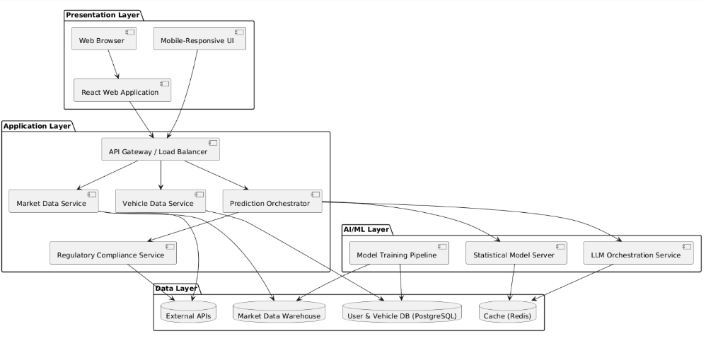
A.2 Data Flow Diagram (Level 1) Source:
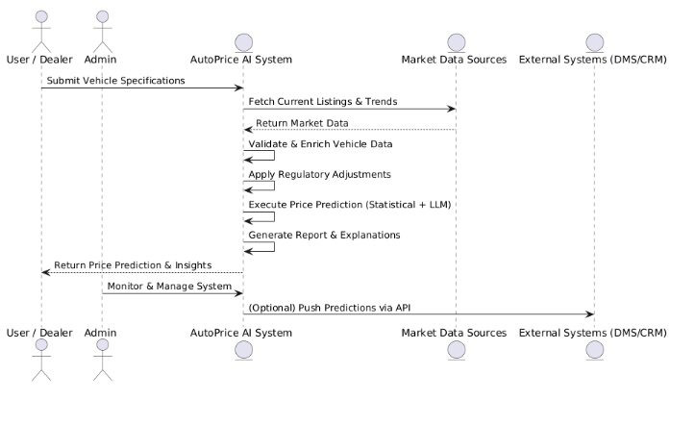
A.3 Use Case Diagram Source:
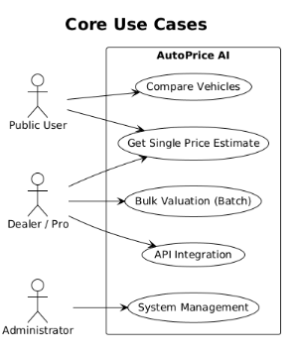
Appendix B: Supported Vehicle Specifications
Table: Initial Supported Vehicle Brands and Models
Brand | Initial Models Supported | Market Focus
Mercedes-Benz | C-Class, E-Class, S-Class, GLC, GLE | Premium Segment
BMW | 3 Series, 5 Series, X3, X5 | Premium Segment
Audi | A3, A4, A6, Q3, Q5 | Premium Segment
Volkswagen | Golf, Passat, Tiguan, Touran | Volume Segment
Peugeot | 208, 308, 3008, 5008 | Volume Segment
Ford | Focus, Fiesta, Kuga, Puma | Volume Segment
Kia | Sportage, Niro, Ceed, Picanto | Value Segment
Volvo | XC40, XC60, XC90, S60 | Premium Segment
Additional models will be added based on market demand and data availability.
Appendix C: EU Emission Standards Reference
Table: Euro Emission Standards Timeline
Euro Standard | Implementation Date | Key Requirements | Price Impact Factor
Euro 1 | 1992 | Basic catalytic converters | 0.3 (heavily depreciated)
Euro 2 | 1996 | Lower CO and HC limits | 0.4
Euro 3 | 2000 | Cold start emissions testing | 0.5
Euro 4 | 2005 | Further reduction in NOx | 0.6
Euro 5 | 2009 | Particulate filters for diesels | 0.8
Euro 6 | 2014 | Real driving emissions (RDE) | 1.0 (baseline)
Euro 6d | 2020 | Stricter RDE testing | 1.1
Euro 7 | 2025 (expected) | EV-focused standards | 1.2 (projected)
Appendix D: Revision History
Table: Document Revision History
Version | Date | Author | Description of Change | Approval Status
1.0 Draft | 2025-10-26 | [Your Name] | Initial creation of FRD for AutoPrice AI | Draft for Review
0.9 | 2025-10-20 | [Team Member] | Initial draft with core requirements | Internal Review
0.8 | 2025-10-15 | [Team Member] | Added non-functional requirements | Technical Review
0.7 | 2025-10-10 | [Team Member] | First complete draft structure | Stakeholder Review
Approval Signatures:
Product Owner: ________________________ Date: __________
Technical Lead: ________________________ Date: __________
Quality Assurance: _____________________ Date: __________
Stakeholder Representative: _____________ Date: __________

